📘 Assignment: Data Backup & Recovery

🔹 Task 1: Backup WhatsApp Chat History
Objective: Create a backup of your WhatsApp chat history and verify that the backup has been created.
Steps:
1. Open WhatsApp
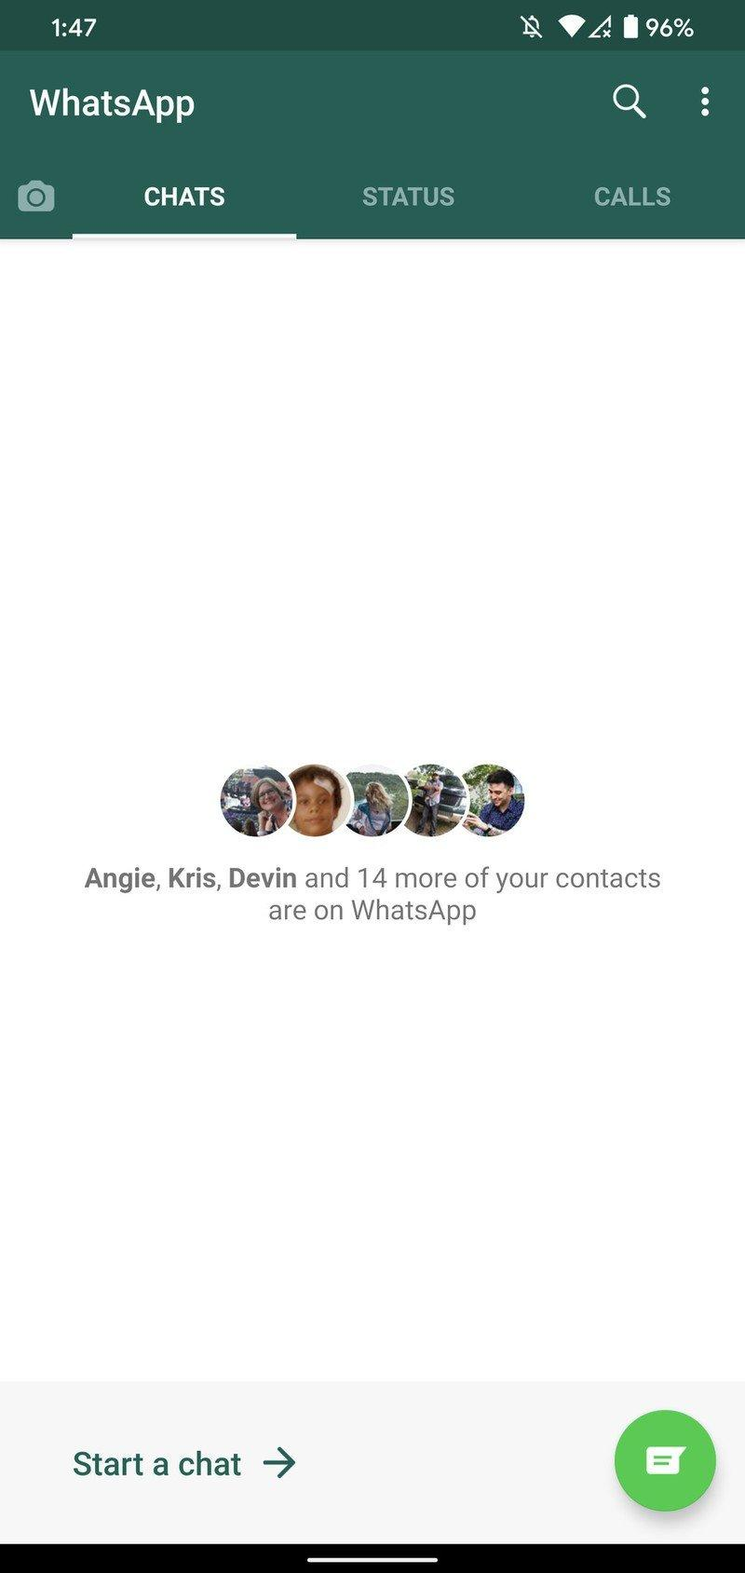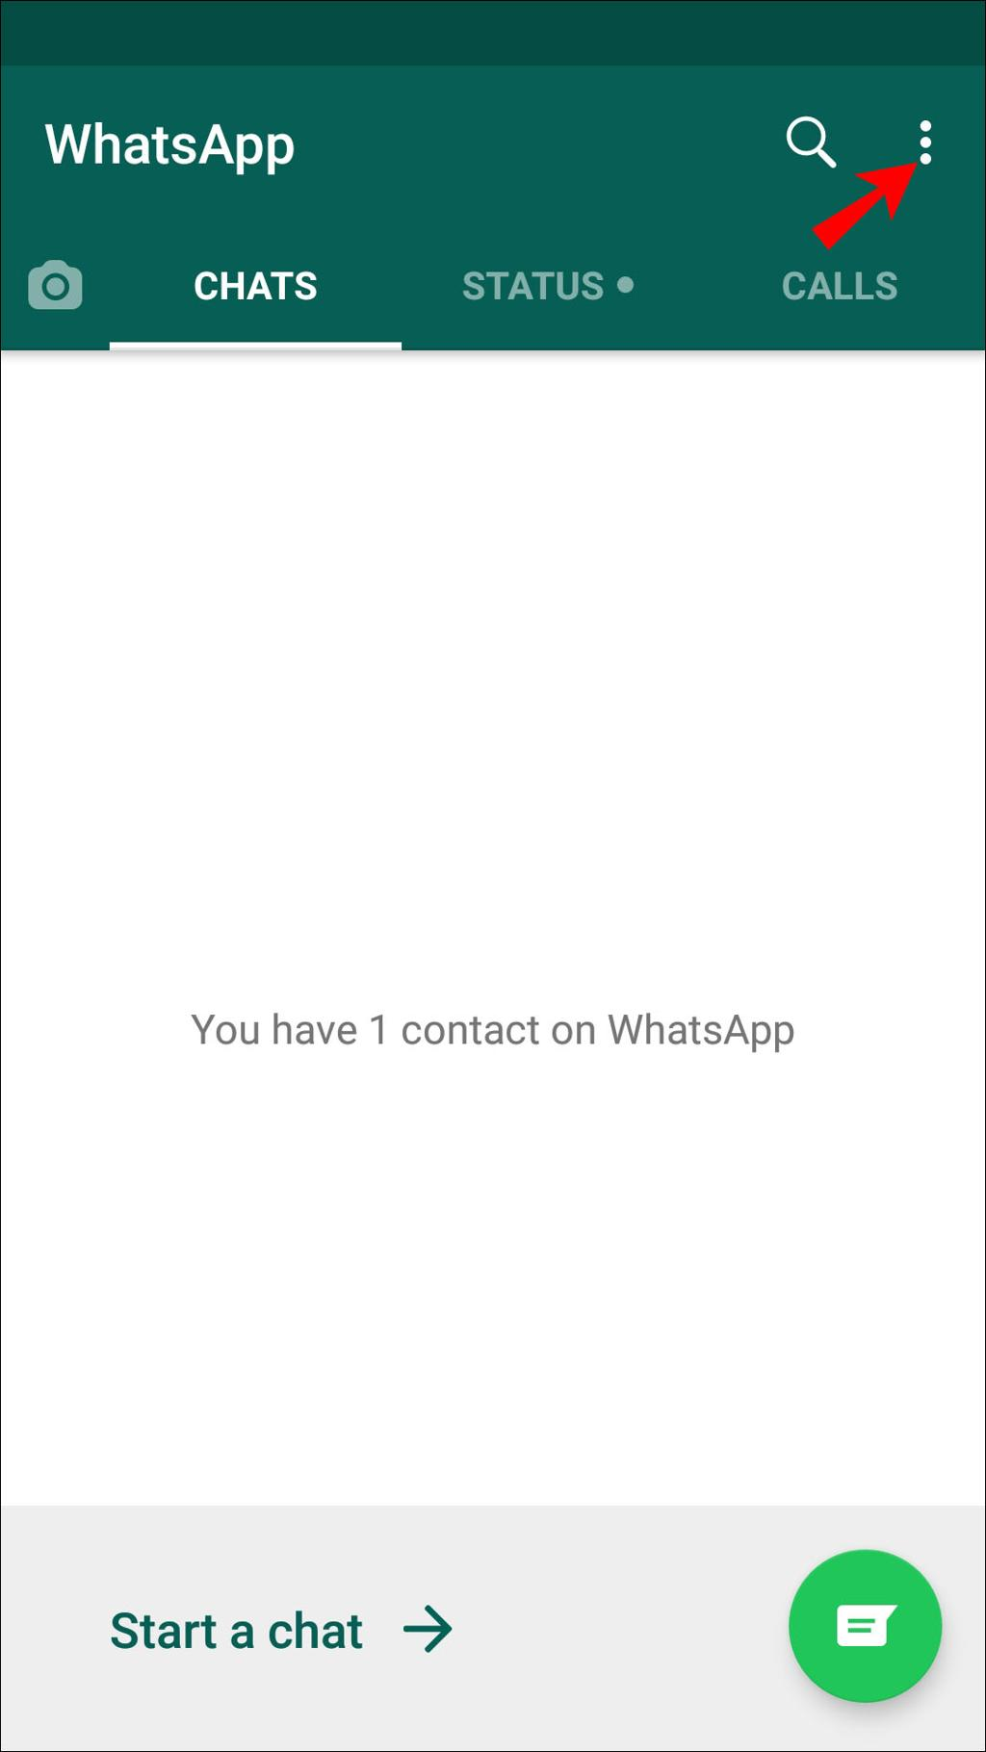

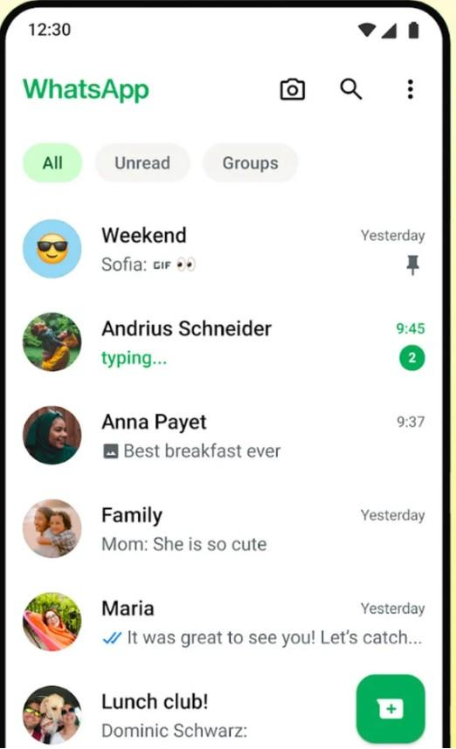
Caption:
Step 1: Open the WhatsApp application on your Android phone.

2. Tap ⋮ (Three Dots) → Settings
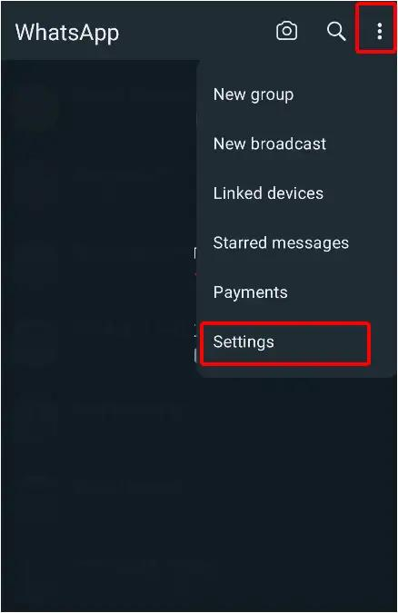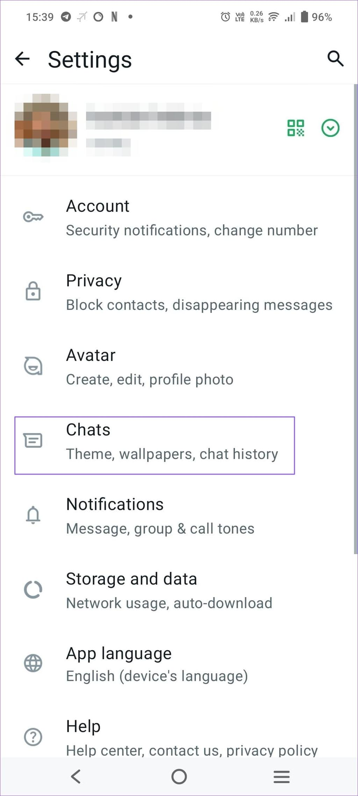

Caption:
Step 2: Tap the three-dot menu in the top-right corner and select Settings.

3. Open Chats → Chat Backup
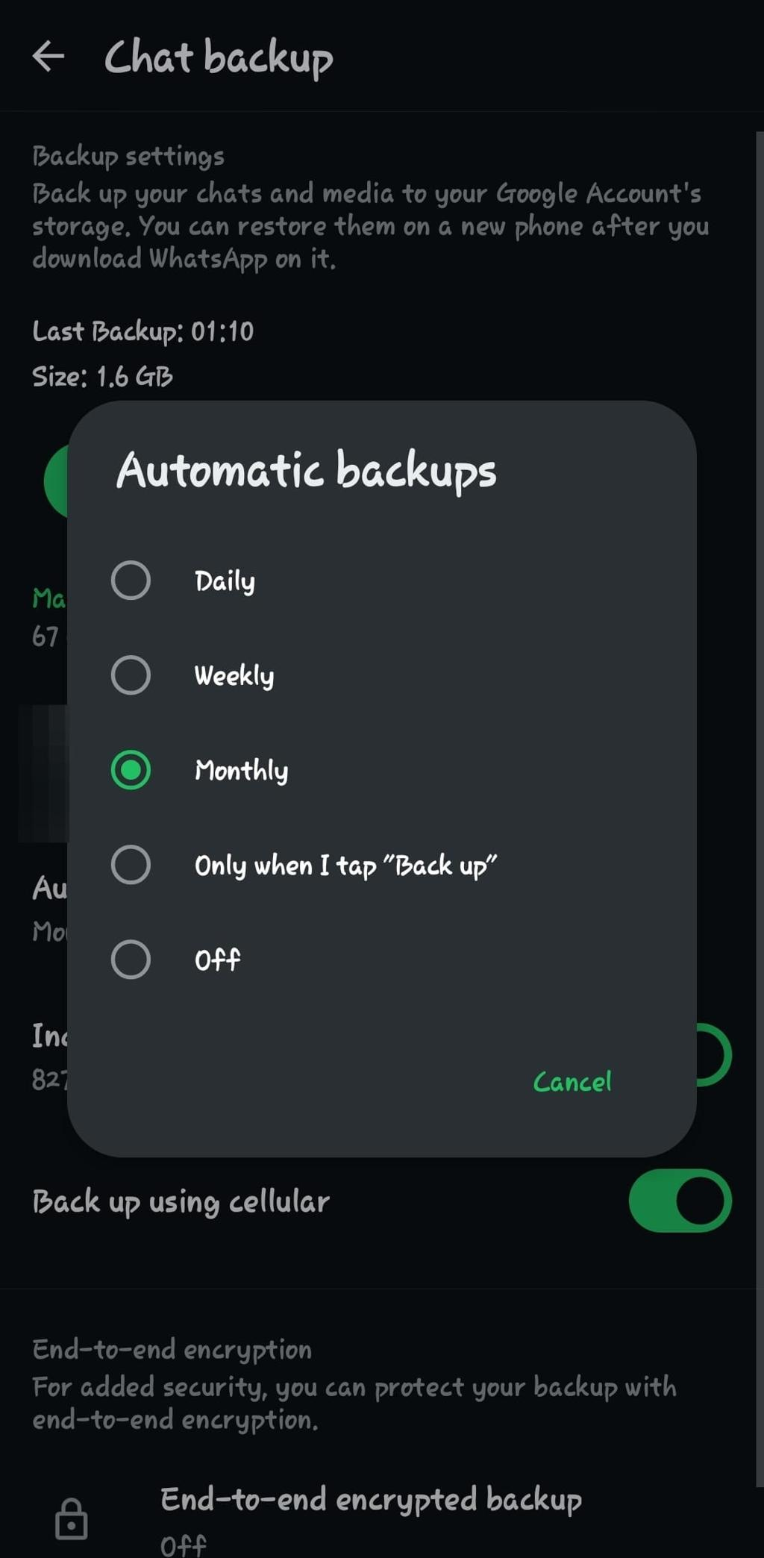
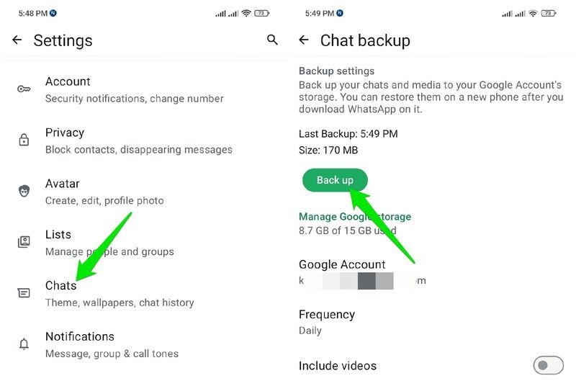
Caption:
Step 3: Navigate to Settings → Chats → Chat Backup.

4. Tap "Back Up"
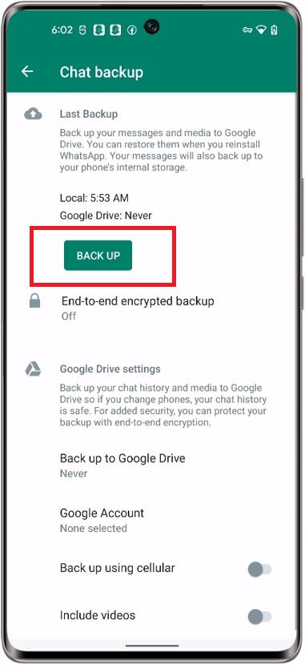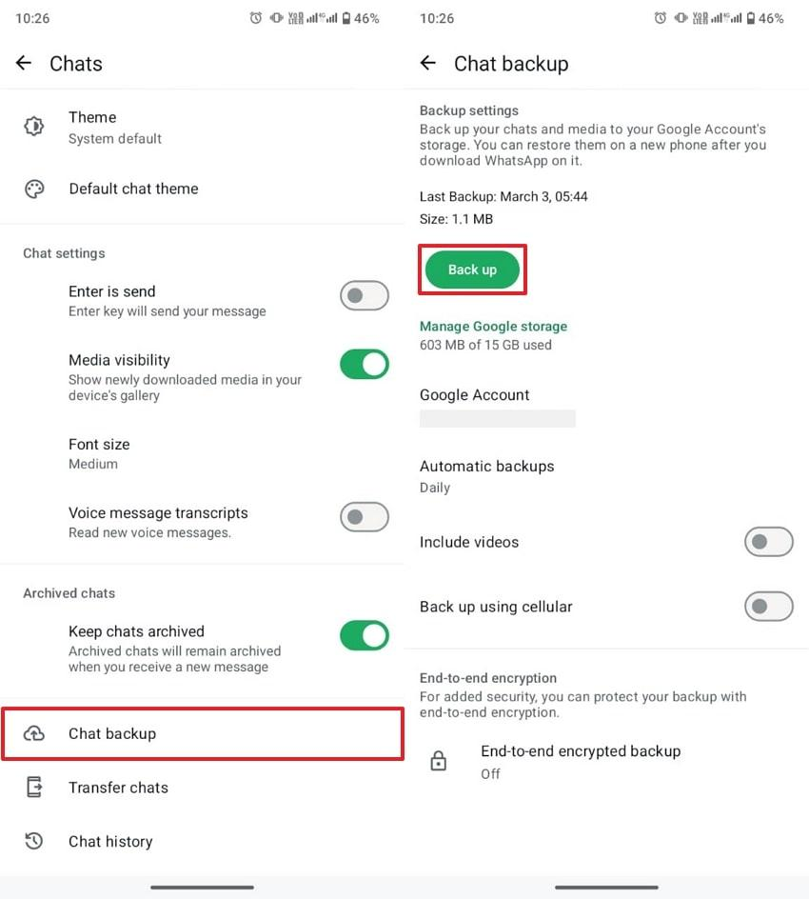
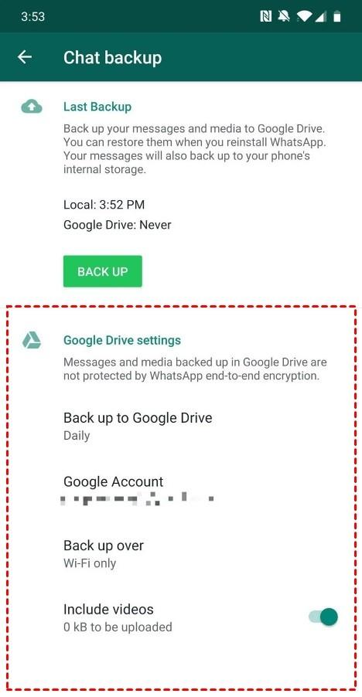

4
Caption:
Step 4: Tap the Back Up button to start creating a backup.

5. Backup in Progress
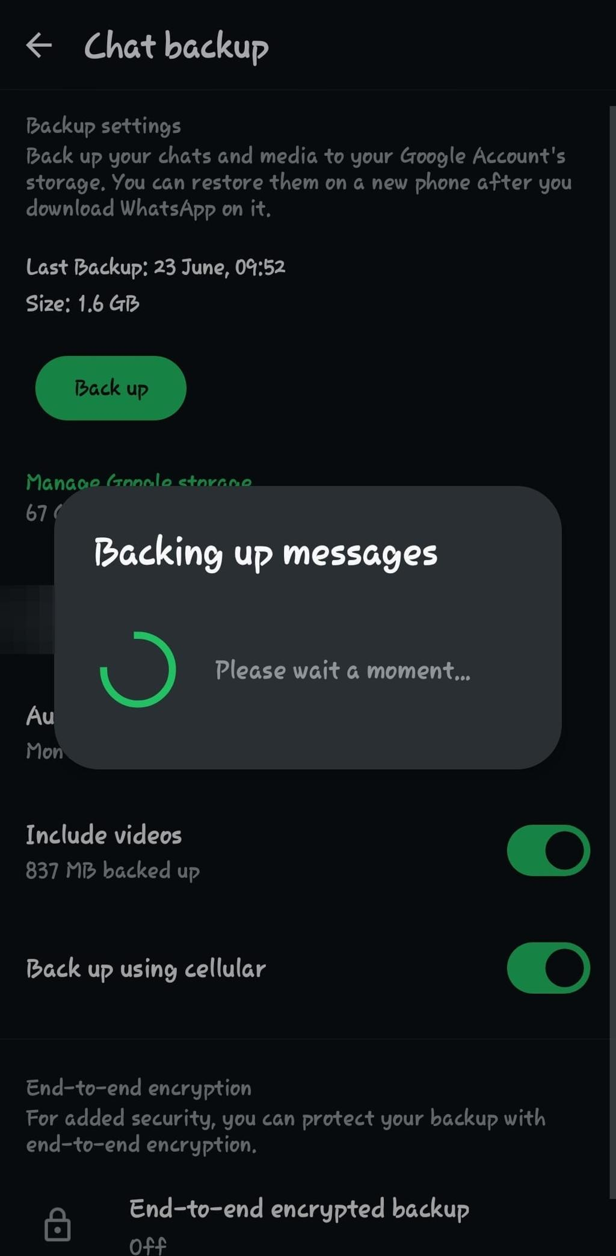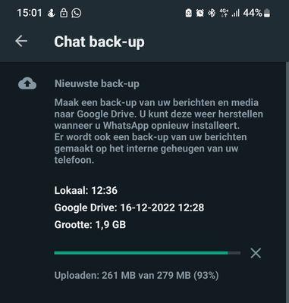

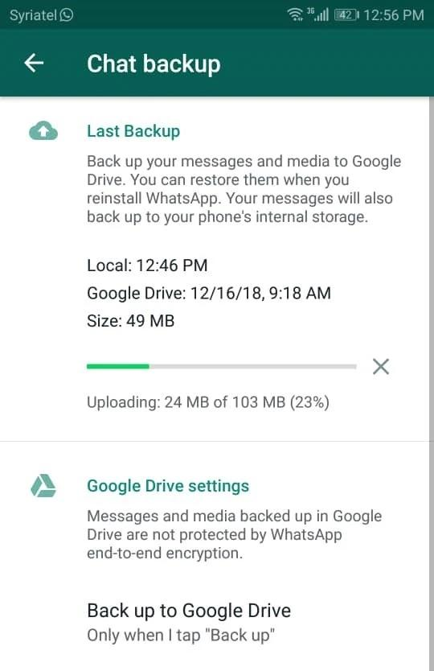
5
Caption:
Step 5: Wait while WhatsApp completes the backup process.

6. Backup Completed Successfully
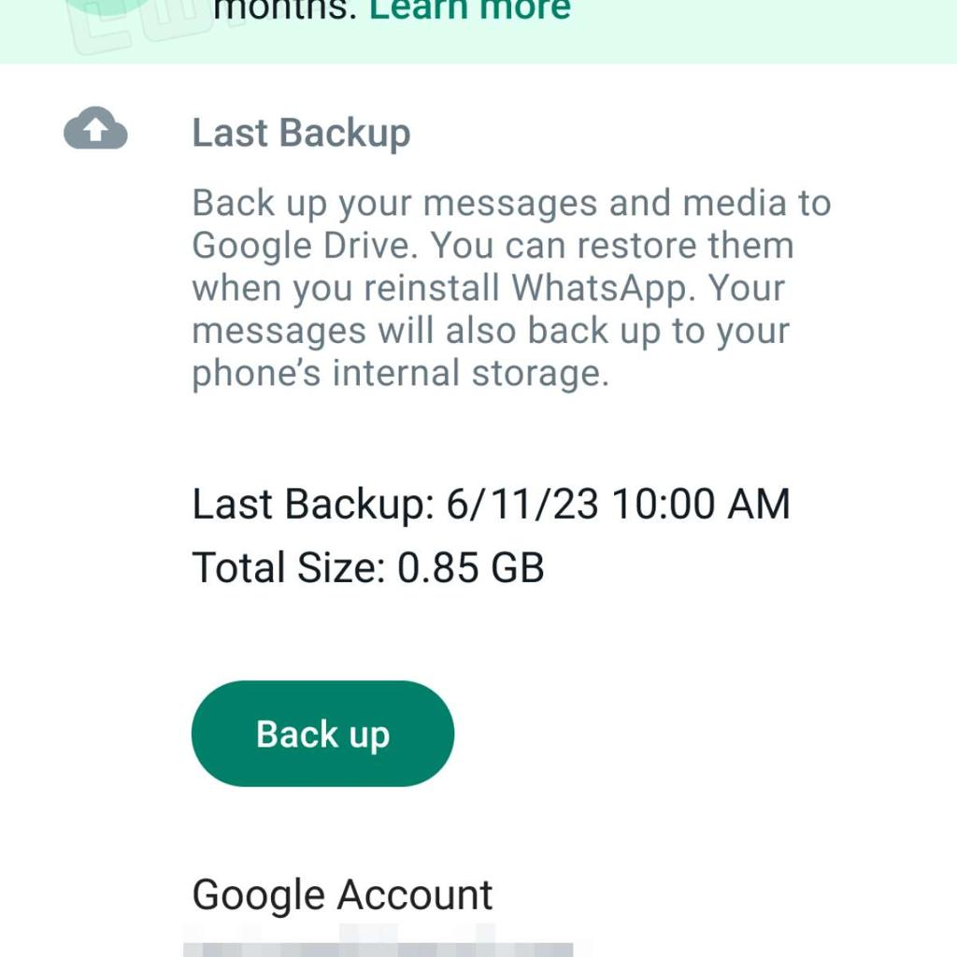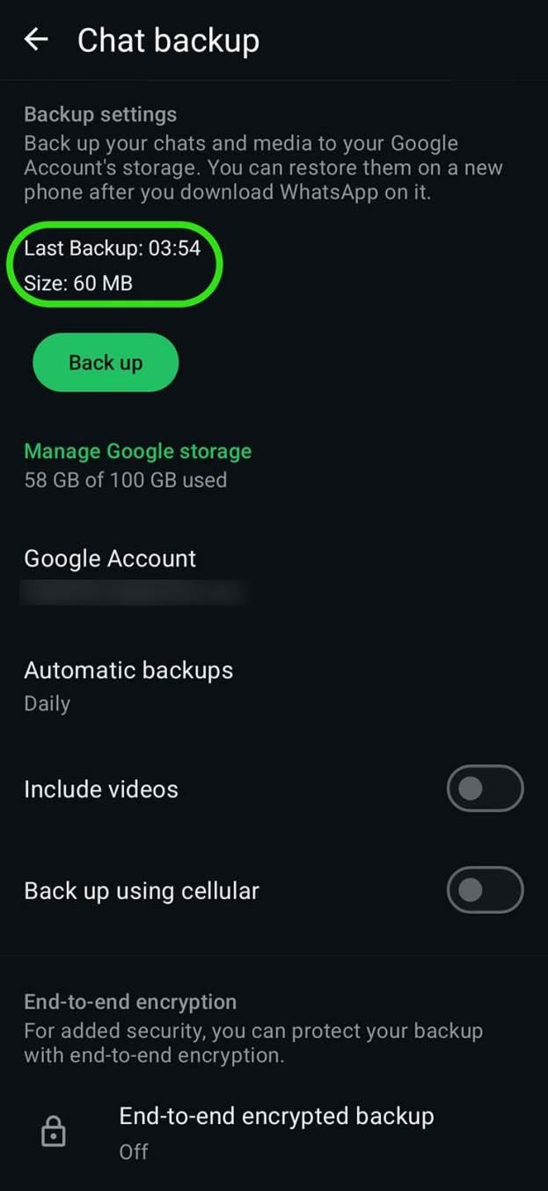

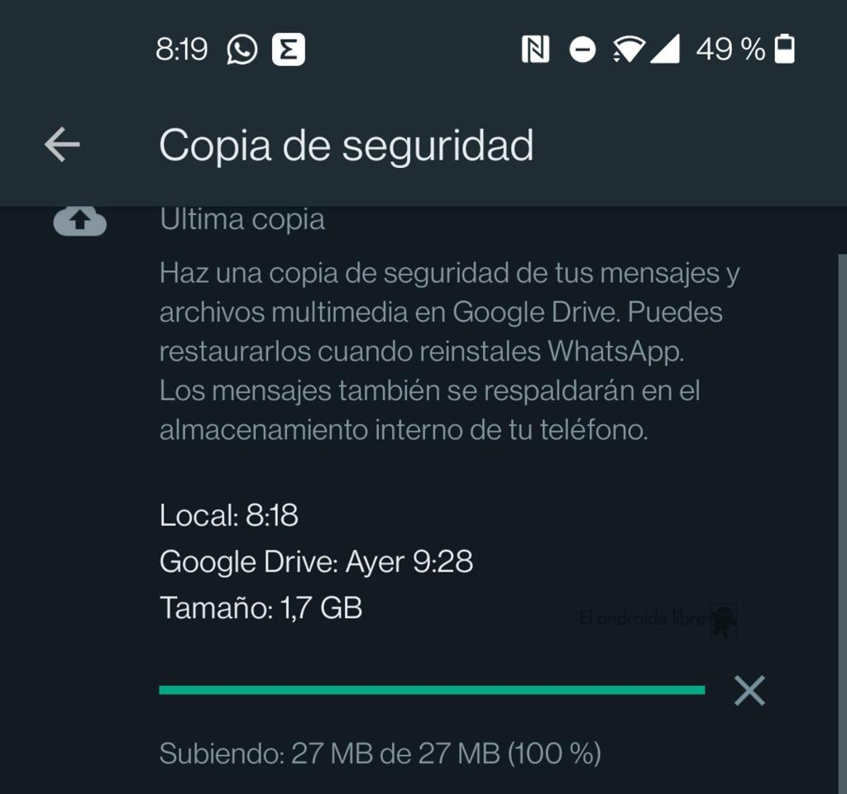
Caption:
Step 6: Verify that the backup has completed successfully and the Last Backup date and time are updated.

7. Verify Backup in Google Drive
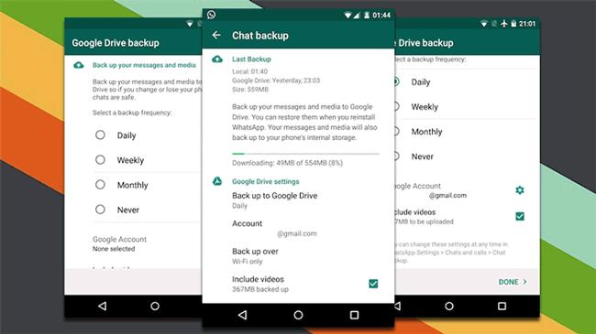
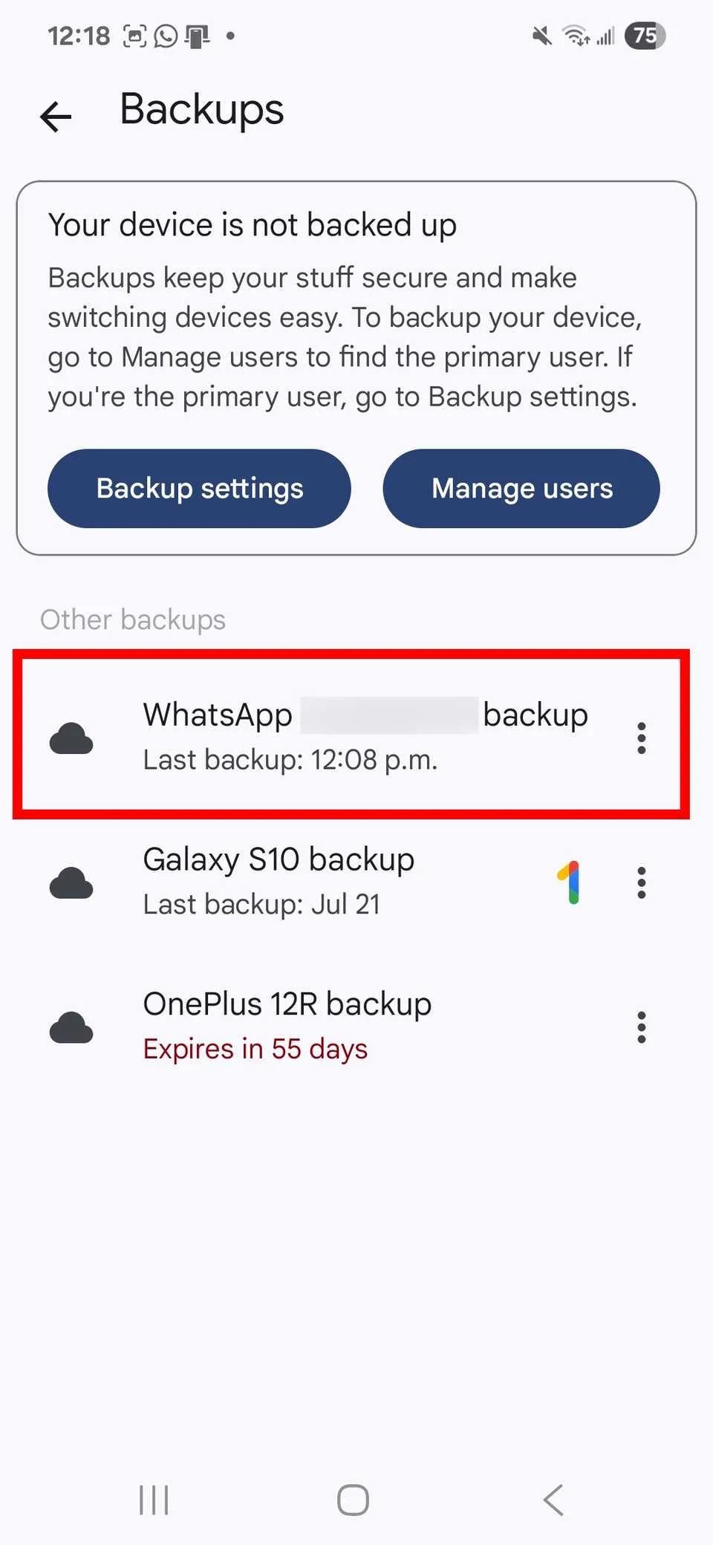
Caption:
Step 7: Open Google Drive → Storage → Backups and verify that the WhatsApp backup is listed.

8. Verify Local Backup File (Android)
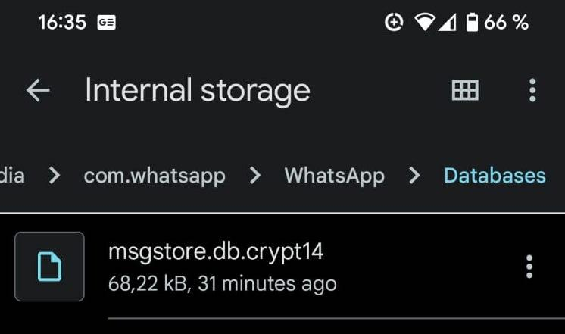
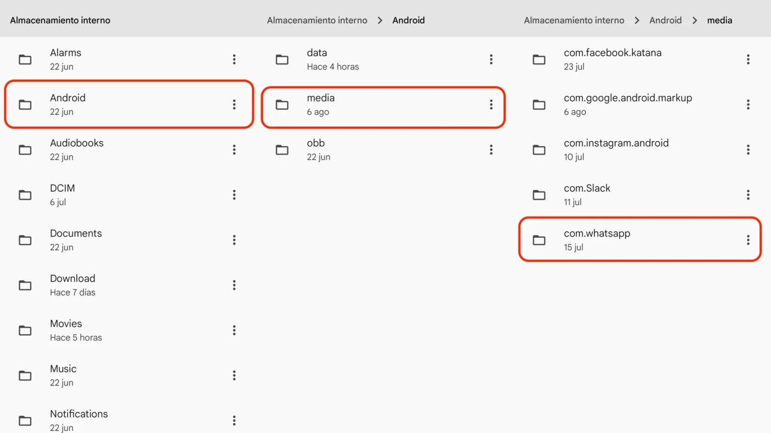

Task 2: Restore Deleted Photos
Objective: Simulate accidental deletion and recover photos.
Steps:
- Open your phone's Gallery app.
- Select 3 photos.
- Tap Delete.
- Open the Trash or Recently Deleted folder.
- Select the deleted photos.
- Tap Restore.
Verification
Confirm that the restored photos appear again in the Gallery.
Task 3: Automatic Contact Backup
Objective: Configure automatic contact backup.
For Android (Google Account)
- Open Settings.
- Go to Google → Backup.
- Enable Back up to Google Drive.
- Open Settings → Passwords & Accounts.
- Select your Google Account.
- Enable Contacts synchronization.
- Tap Sync Now.
For iPhone (iCloud)
- Open Settings.
- Tap your Apple ID.
- Select iCloud.
- Turn Contacts ON.
- Enable iCloud Backup.
Why This Is Important
- Contacts are restored automatically after changing or resetting your phone.
- Prevents permanent loss of important contact information.

Task 4: Export YouTube Playlist Using Google Takeout
Steps
1. Open Google Takeout
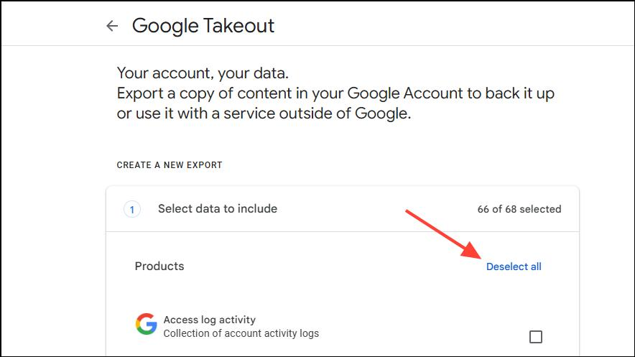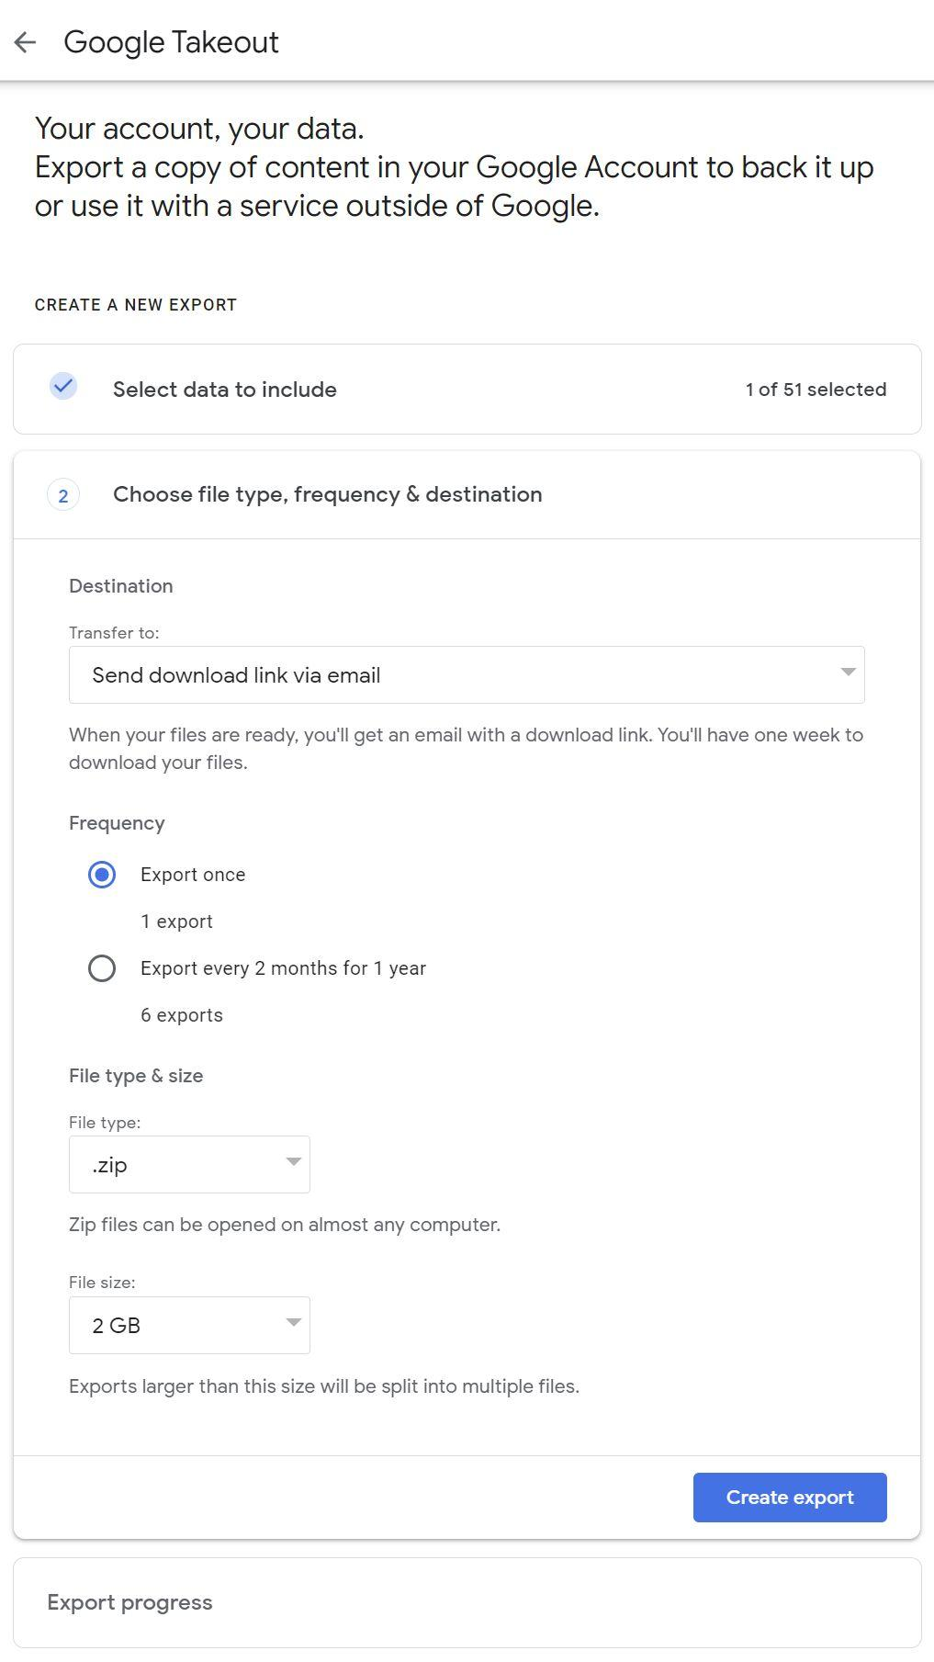

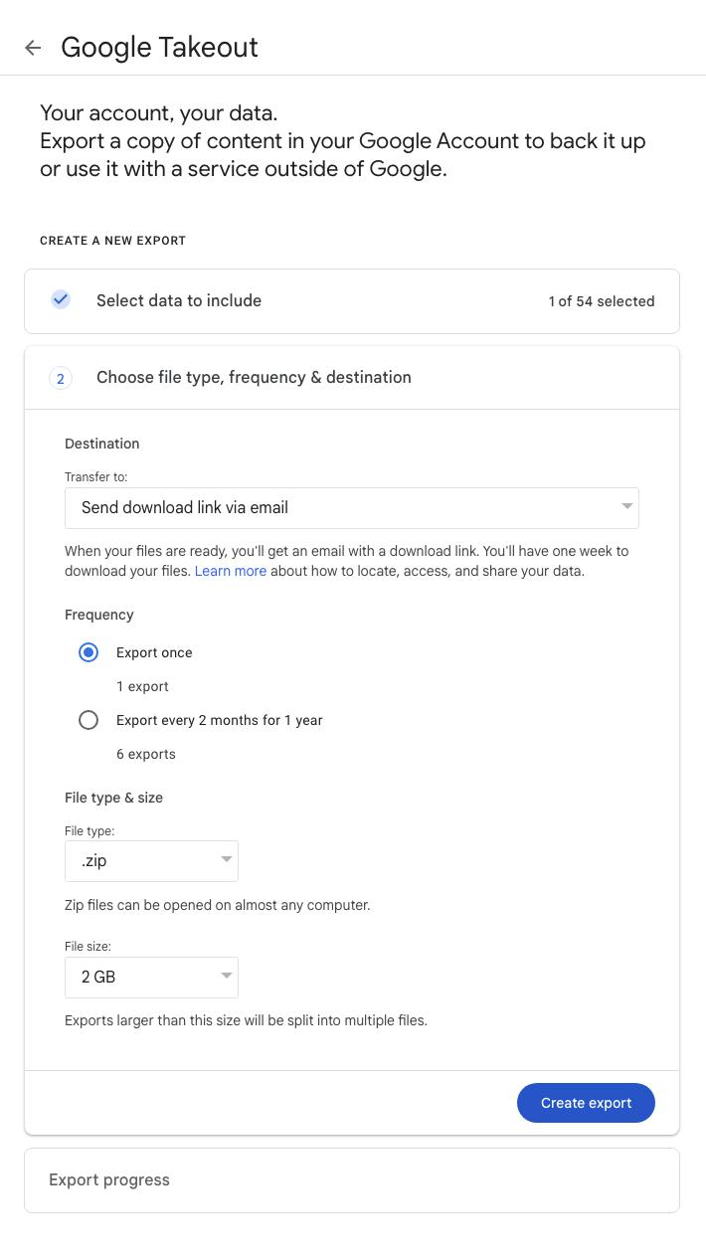
Caption:
Step 1: Open Google Takeout and sign in with your Google account.

2. Click "Deselect All"
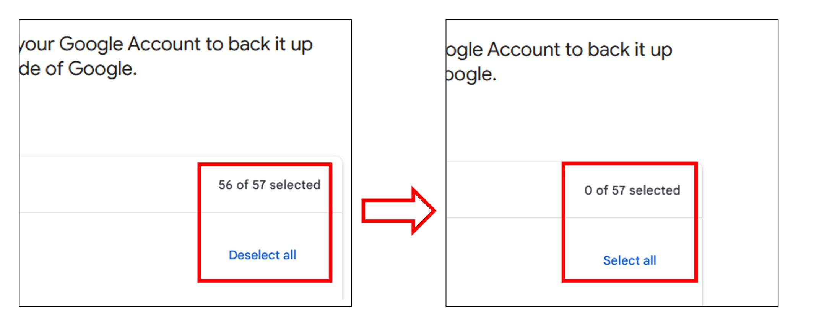
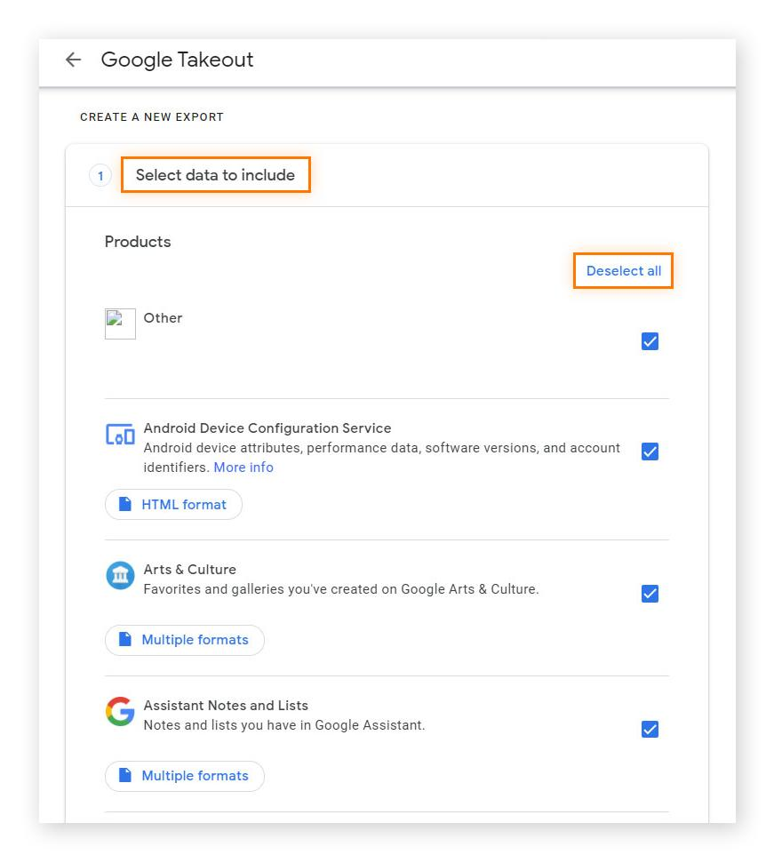
Caption:
Step 2: Click Deselect all to clear the default selections.

3. Select "YouTube and YouTube Music"
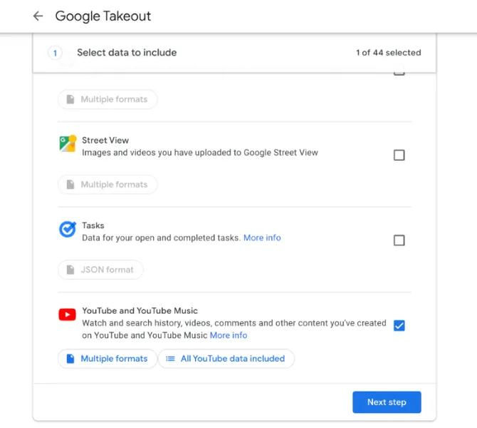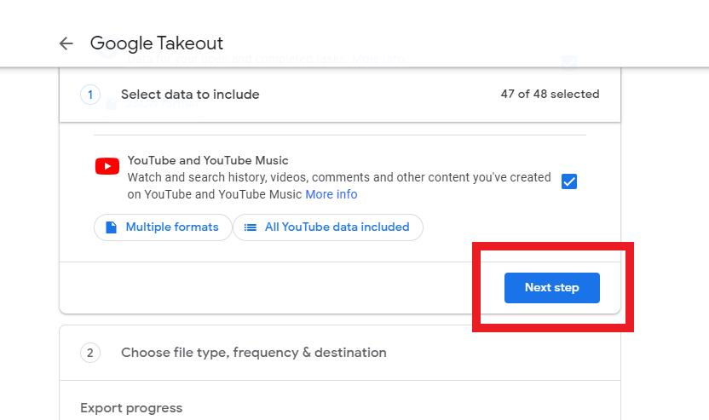
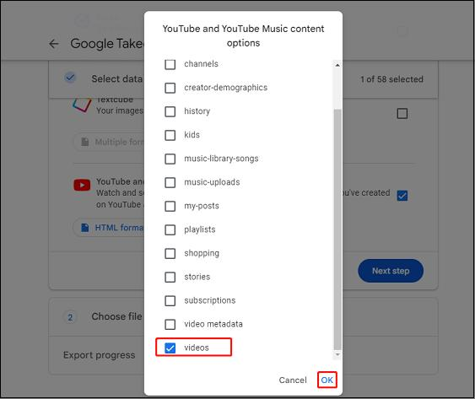
Caption:
Step 3: Scroll down and select YouTube and YouTube Music.

4. Click "Next Step"
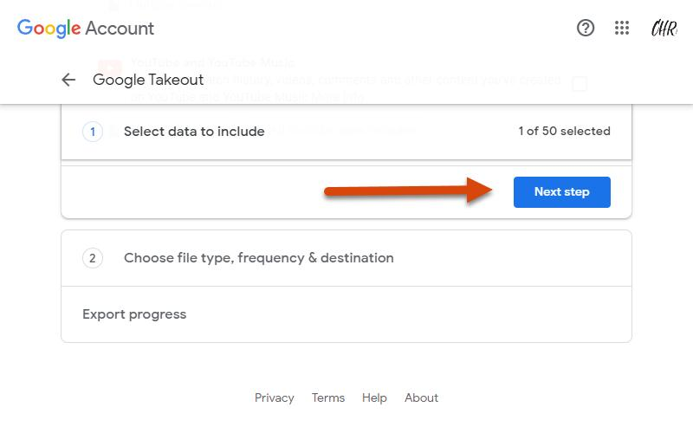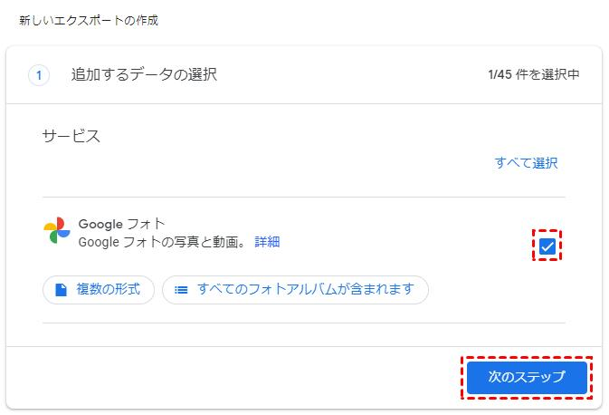

Caption:
Step 4: Click Next Step to continue.

5. Choose Export Options
- Export Once
- ZIP format
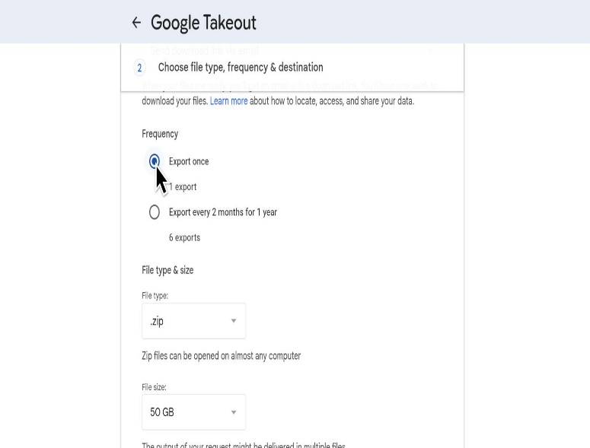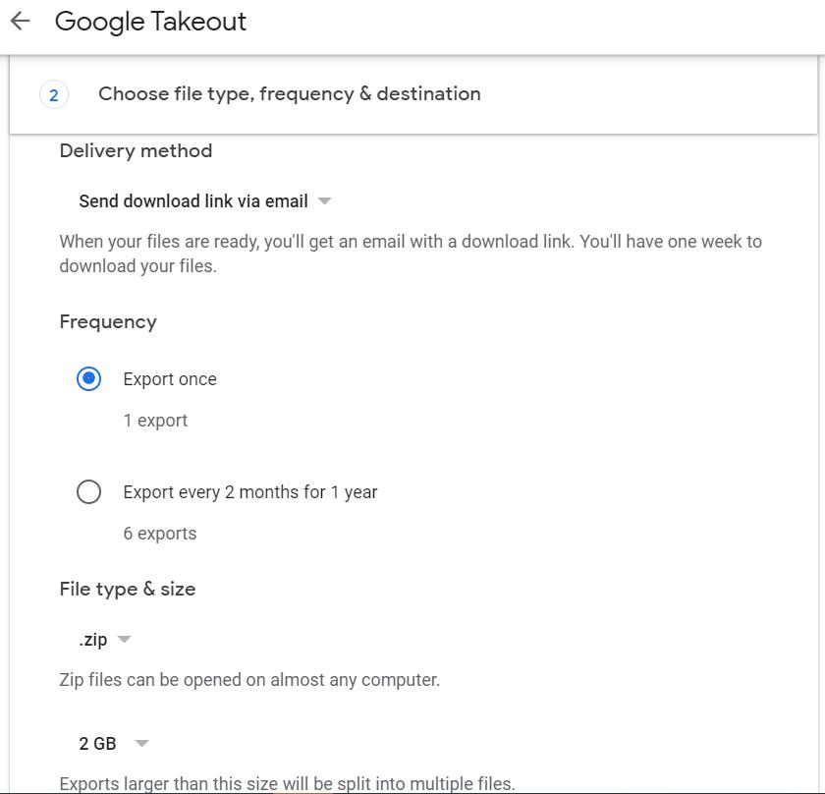

Caption:
Step 5: Select Export Once and choose ZIP as the file format.

6. Click "Create Export"
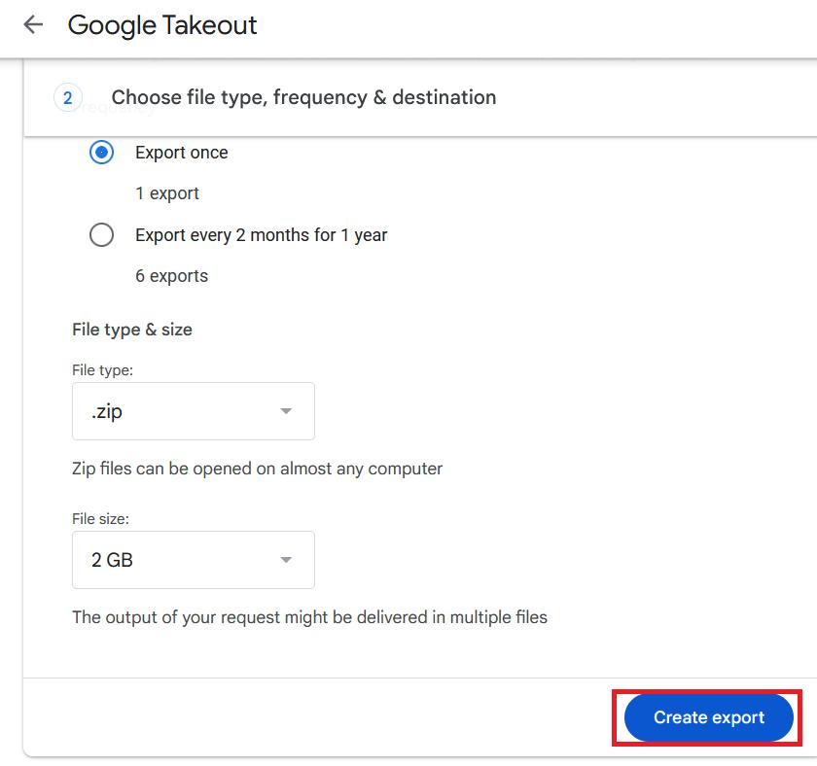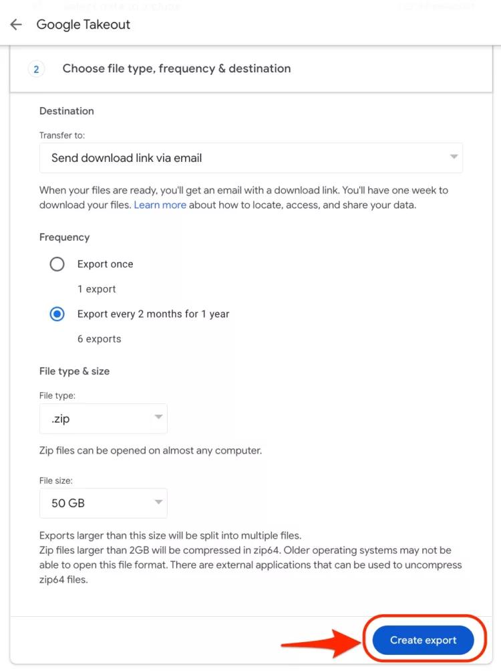

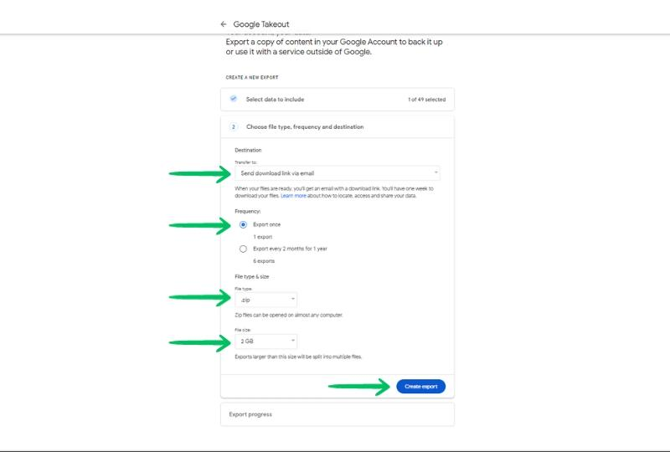
Caption:
Step 6: Click Create Export to begin generating the archive.

7. Download the ZIP File
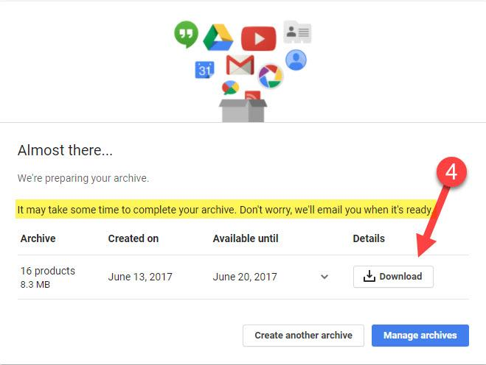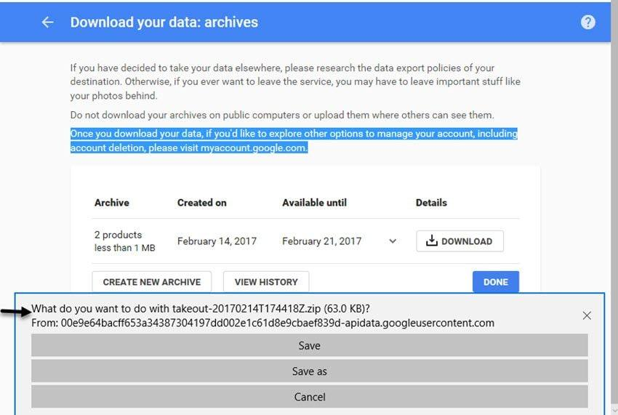

Caption:
Step 7: Once the export is ready, download the ZIP archive.

8. Extract the ZIP File
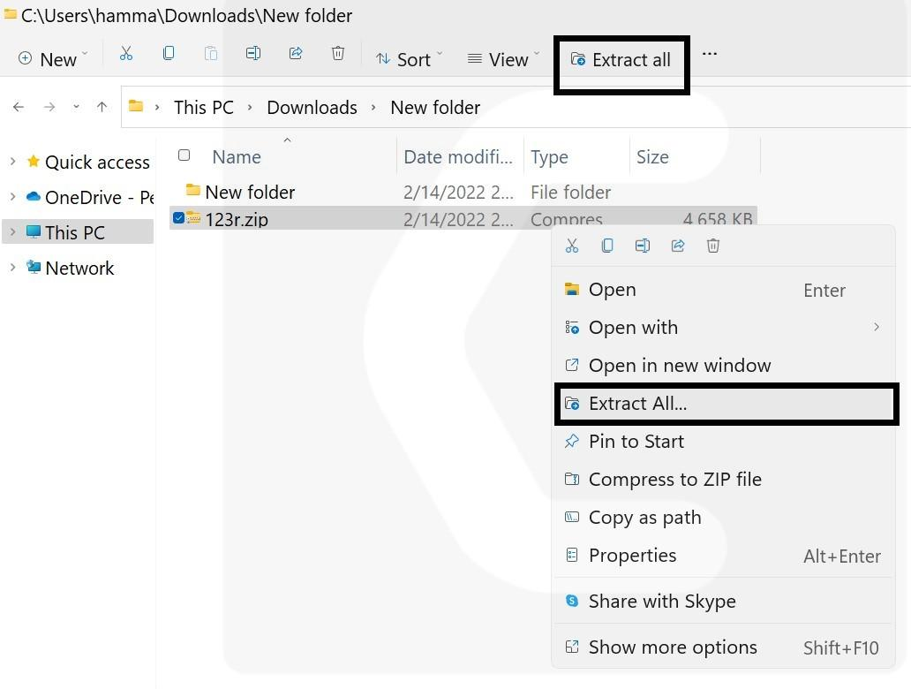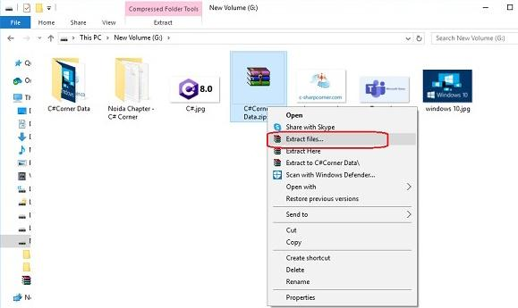

Caption:
Step 8: Extract the downloaded ZIP file using Extract All.

9. Open the Extracted Folder
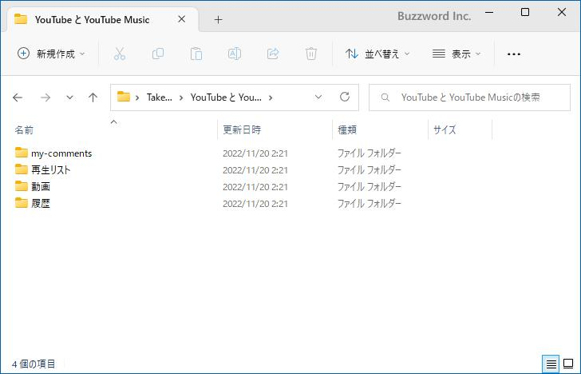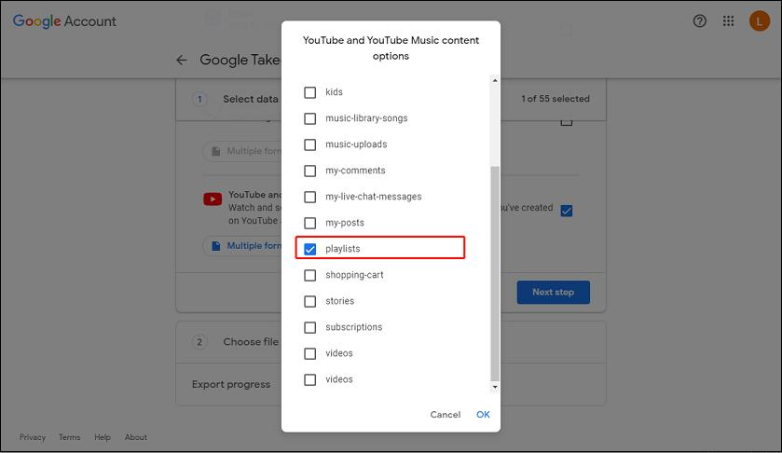

Caption:
Step 9: Open the extracted folder and navigate to the YouTube and YouTube Music directory.

10. Locate Playlist Information
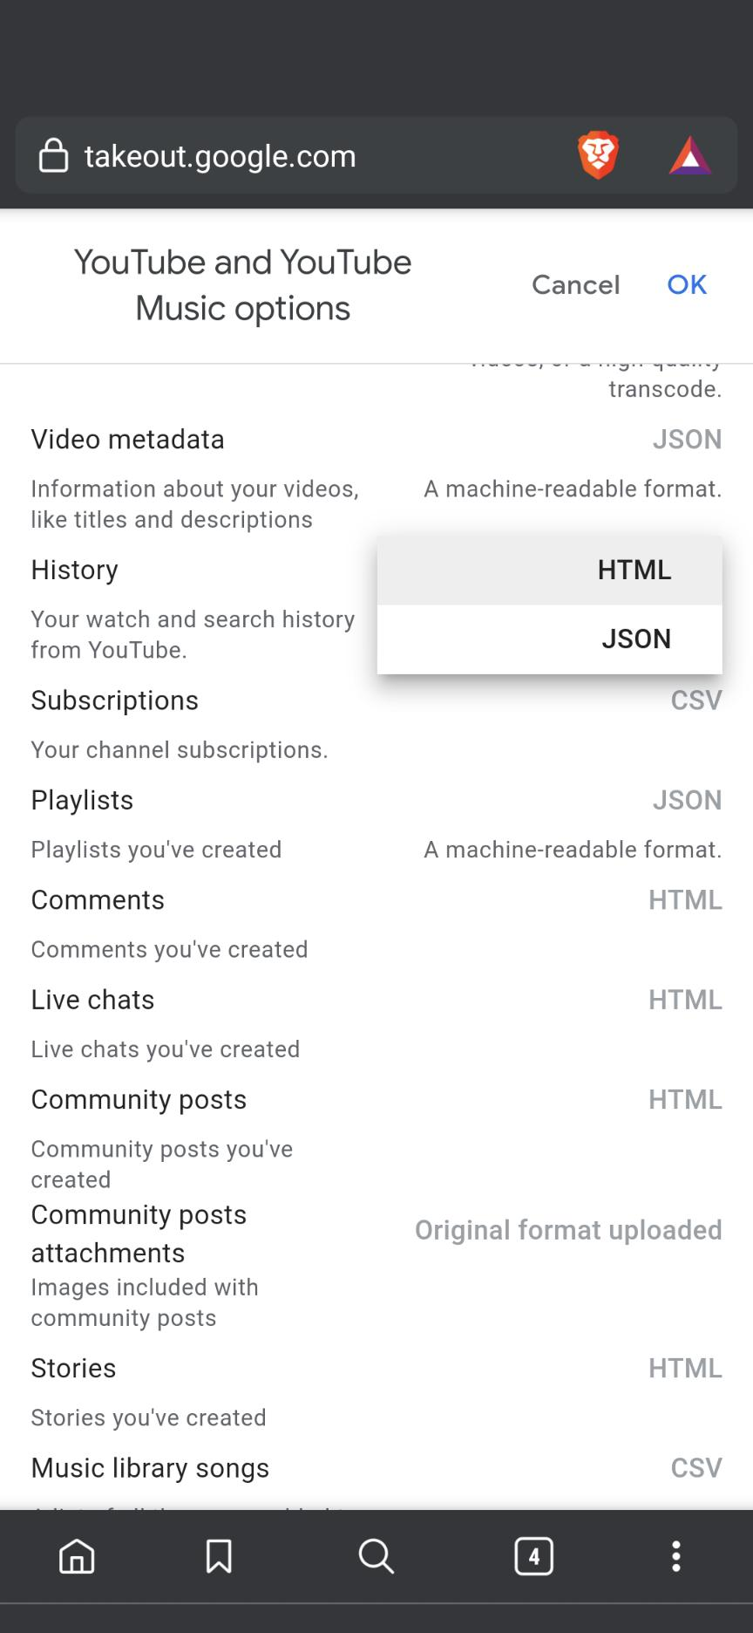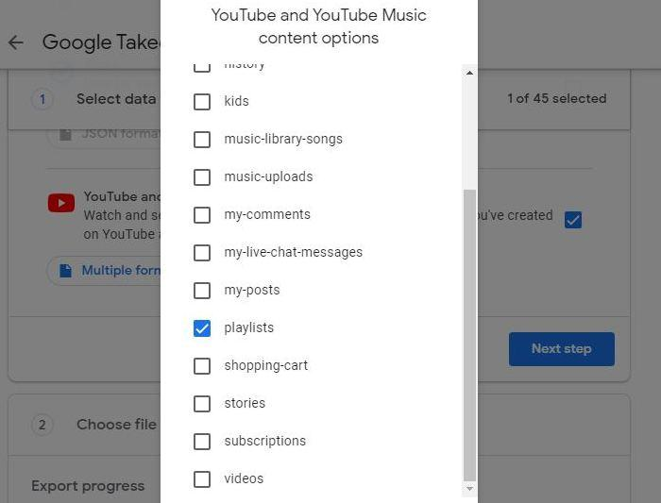

Task 5: Restore a Deleted File from Google Drive
Steps
- Open Google Drive or the Google Drive website.
- Upload a sample file (e.g., sample.txt).
- Delete the uploaded file.
- Open the Trash folder.
- Right-click (or tap the three dots) on the file.
- Select Restore.
- Verify that the file is available again in My Drive.

